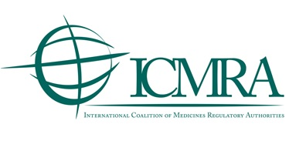

Submission of comments on: 'Recommendations on Common Technical Denominators for Track and Trace (T&T) Systems to Allow for Interoperability'

Please submit your comments to: icmratrackandtrace@ema.europa.eu by 28th February 2021 at the latest

<Date of submission>

Comments from:
Name of organisation or individual

- General comments
General commentS
Please add more rows if needed.

- Specific comments on text
Line no. | Comment and rationale; proposed changes
Comment:

Proposed change (if any):

Comment:

Proposed change (if any):

Comment:

Proposed change (if any):

Please add more rows if needed.

